SOFTWARE REQUIREMENTS SPECIFICATION
Bug and Issue Tracking System

Software Engineering Project
SRS Version 1.0
Prepared by: Group D
Rokka Sushmita (2401445)
Sharma Binita (2401479)
Tamang Som Bahadur (2401536)
Thapa Pharendra Raj (2401546)
Lungyeli Sijan Magar (2401446)
Dongshin University
Oct 2026

Project Technology
React / Vite • Node.js / Express.js • MySQL
Revision History
Name / Group | Date | Reason for Changes | Version
Group D | October 2026 | Initial SRS document | 1.0

Table of Contents
1. Introduction
1.1 Purpose
1.2 Document Conventions
1.3 Intended Audience and Reading Suggestions
1.4 Product Scope
1.5 References
2. Overall Description
2.1 Product Perspective
2.2 Product Functions
2.3 User Classes and Characteristics
2.4 Operating Environment
2.5 Design and Implementation Constraints
2.6 User Documentation
2.7 Assumptions and Dependencies
3. External Interface Requirements
3.1 User Interfaces
3.2 Hardware Interfaces
3.3 Software Interfaces
3.4 Communications Interfaces
4. System Features
4.1 User Authentication and Authorization
4.2 Bug and Issue Reporting
4.3 Bug Assignment and Tracking
4.4 Status Management
4.5 Priority and Severity Management
4.6 Search and Filtering
4.7 Comments and History
4.8 Testing and Reopening
4.9 Dashboard and Reporting
4.10 User Management
4.11 Issue Life Cycle
5. Other Nonfunctional Requirements
5.1 Performance Requirements
5.2 Safety Requirements
5.3 Security Requirements
5.4 Software Quality Attributes
5.5 Business Rules
6. Other Requirements
Appendix A: Glossary
Appendix B: Analysis Models
Appendix C: To Be Determined List

1. Introduction

1.1 Purpose
The purpose of the Bug and Issue Tracking System is to provide a web-based platform for reporting, organizing, assigning, tracking, testing, and resolving software bugs and issues. The system will provide a centralized place for a software project team to manage issues throughout their life cycle and to maintain a history of changes.

1.2 Document Conventions
This document describes the functional and nonfunctional requirements of the proposed system. The term “shall” indicates a mandatory requirement. The term “should” indicates a recommended characteristic or behavior. Each system feature in Section 4 is assigned a High, Medium, or Low priority, and the detailed requirements of a feature inherit the priority of that feature.
Term | Meaning
Bug / Issue | A reported software problem, error, or development issue.
Priority | The urgency with which an issue should be addressed.
Severity | The impact of an issue on the software.
Status | The current stage of an issue in its life cycle.
Administrator | A user responsible for system and user administration.
Developer | A user who investigates and fixes assigned issues.
Tester / QA | A user who verifies whether an issue has been fixed.

1.3 Intended Audience and Reading Suggestions
This SRS is intended for the project team, software developers, testers, project managers, system administrators, and the course instructor. Readers should first review Sections 1 and 2 for project context, then Sections 3 and 4 for interface and functional requirements, and finally Section 5 for nonfunctional requirements.

1.4 Product Scope
The system will support the reporting and management of software bugs and issues within a project. Users will be able to create issue reports, view and search issues, assign issues to developers, update status, set priority and severity, add comments, record testing results, and monitor project progress. The system is intended to reduce manual tracking and improve visibility of issue resolution.
- Centralized bug and issue records.
- Role-based access for project participants.
- Issue assignment and status tracking.
- Search and filtering by important issue attributes.
- Comments and history for traceability.
- Dashboard information for monitoring progress.

1.5 References
- Software Engineering course materials and lecture notes.
- Course SRS template provided by the instructor.
- React and Vite project documentation.
- Node.js and Express.js documentation.
- MySQL documentation.

2. Overall Description

2.1 Product Perspective
The Bug and Issue Tracking System will be a web application. The user interface will be developed using React and Vite, the server-side application will use Node.js and Express.js, and MySQL will store persistent application data. The application will be accessed through a modern web browser.
High-level architecture:
Layer | Technology / Responsibility
Presentation Layer | React + Vite; web pages and user interaction.
Application Layer | Node.js + Express.js; REST API and business logic.
Data Layer | MySQL; users, projects, issues, comments, and history.

2.2 Product Functions
- Authenticate users and enforce role-based permissions.
- Create, view, edit, and track bugs and issues.
- Assign issues to appropriate developers.
- Set and update issue priority, severity, and status.
- Search and filter issue records.
- Add comments and maintain issue history.
- Test fixed issues and reopen issues when necessary.
- Display project issue statistics through a dashboard.
- Allow administrators to manage user accounts and roles.

2.3 User Classes and Characteristics
User Class | Characteristics / Main Responsibilities
System Administrator | Manages user accounts, roles, and system-level access.
Project Manager | Monitors issues, assigns work, and tracks project progress.
Developer | Works on assigned issues, records progress, and submits fixes.
Tester / QA | Tests fixes and closes or reopens issues based on results.
Project Team Member | Reports issues and views relevant issue information.

2.4 Operating Environment
- Client operating systems: Windows, macOS, or Linux.
- Modern web browser such as Chrome, Edge, Safari, or Firefox.
- Node.js runtime for the server application.
- MySQL database server.
- Development using Visual Studio Code or an equivalent IDE.

2.5 Design and Implementation Constraints
- The system shall be implemented as a web application.
- React/Vite shall be used for the frontend.
- Node.js and Express.js shall be used for the backend.
- MySQL shall be used as the primary relational database.
- The project shall remain achievable within the academic project schedule.
- Only authorized users shall access protected functions.

2.6 User Documentation
The project will provide basic user instructions covering login, issue reporting, issue assignment, status updates, searching/filtering, comments, and testing/closing or reopening issues.

2.7 Assumptions and Dependencies
- Users have valid accounts and appropriate permissions.
- The database server is available when the application is being used.
- Users enter sufficiently accurate issue information.
- The project team maintains the application and database.
- The final scope of any external integrations may be adjusted during implementation.

3. External Interface Requirements

3.1 User Interfaces
The system will provide the following major user interfaces:
- Login page for authentication.
- Dashboard showing issue statistics and project status.
- Issue list page with search and filters.
- Create Issue page for reporting a bug or issue.
- Issue Details page showing description, assignment, status, comments, and history.
- User Management page for administrators.
The interface should use consistent navigation, readable labels, validation messages, and clear status indicators.

3.2 Hardware Interfaces
No specialized hardware is required. The system will run on ordinary desktop and laptop computers. Access from tablet and mobile browsers is supported on a best-effort basis, subject to the final interface design.

3.3 Software Interfaces
Interface | Purpose
Web Browser | Provides access to the React/Vite user interface.
Node.js / Express.js | Provides server-side application logic and REST API endpoints.
MySQL | Stores and retrieves application data.

3.4 Communications Interfaces
The frontend and backend will communicate through HTTP/HTTPS requests using REST-style API endpoints. The application will use standard web communication between the browser and server.

4. System Features

4.1 User Authentication and Authorization

4.1.1 Description and Priority
Description: Lets registered users log in and out of the system and restricts protected functions according to the user's role.
Priority: High

4.1.2 Stimulus/Response Sequences
- The user enters a username and password and submits the login form; the system validates the credentials and opens the dashboard.
- The user enters invalid credentials; the system shows an error message and does not create a session.
- The user selects Log out; the system ends the session and returns to the login page.

4.1.3 Functional Requirements
FR-01: The system shall provide a login interface for registered users.
FR-02: The system shall validate submitted credentials before granting access.
FR-03: The system shall restrict protected functions according to the user's role.
FR-04: The system shall provide a logout function.

4.2 Bug and Issue Reporting

4.2.1 Description and Priority
Description: Lets authorized users report a new bug or issue with the details needed to investigate it.
Priority: High

4.2.2 Stimulus/Response Sequences
- The user opens the Create Issue page, enters the title, description, priority, and severity, and submits; the system validates the data, saves the issue, and displays its issue ID.
- The user leaves a required field empty or enters invalid data; the system highlights the problem fields and does not save the issue.

4.2.3 Functional Requirements
FR-05: The system shall allow authorized users to create a new issue.
FR-06: An issue shall have a unique identifier.
FR-07: The system shall record an issue title, description, creator, date, priority, severity, and status.
FR-08: The system shall validate required issue fields before saving an issue.

4.3 Bug Assignment and Tracking

4.3.1 Description and Priority
Description: Lets a project manager assign an issue to a developer and lets users see who is working on an issue.
Priority: High

4.3.2 Stimulus/Response Sequences
- The project manager opens an issue and selects a developer; the system saves the assignment, sets the status to Assigned, and records the change in the issue history.
- The project manager selects an invalid or inactive developer; the system rejects the assignment and shows a message.
- A user opens an issue; the system displays the current assignee and progress.

4.3.3 Functional Requirements
FR-09: The system shall allow an authorized project manager to assign an issue to a developer.
FR-10: The system shall allow users to view the current assignee and issue progress.
FR-11: The system shall maintain the relationship between an issue and its assigned developer.

4.4 Status Management

4.4.1 Description and Priority
Description: Lets authorized users move an issue through its life cycle (see the Issue Life Cycle in Section 4.11) and keeps a record of each change.
Priority: High

4.4.2 Stimulus/Response Sequences
- An authorized user selects a new status for an issue; the system updates the status and records the change in the issue history.
- An unauthorized user tries to change a status; the system rejects the request.

4.4.3 Functional Requirements
FR-12: The system shall support issue statuses including New, Assigned, In Progress, Fixed, Testing, Closed, and Reopened.
FR-13: Authorized users shall be able to update an issue's status.
FR-14: The system shall record important status changes in the issue history.

4.5 Priority and Severity Management

4.5.1 Description and Priority
Description: Lets authorized users set and change how urgent (priority) and how damaging (severity) an issue is.
Priority: Medium

4.5.2 Stimulus/Response Sequences
- An authorized user changes the priority or severity of an issue and saves; the system stores the new value and records the change in the issue history.

4.5.3 Functional Requirements
FR-15: The system shall support the priority levels Low, Medium, High, and Critical.
FR-16: The system shall support the severity levels Minor, Moderate, Major, and Critical.
FR-17: Authorized users shall be able to update priority and severity.

4.6 Search and Filtering

4.6.1 Description and Priority
Description: Lets users find issues by keyword and narrow the issue list with filters.
Priority: Medium

4.6.2 Stimulus/Response Sequences
- The user enters a keyword or selects one or more filters; the system displays the matching issues.
- No issue matches; the system displays an empty-state message.

4.6.3 Functional Requirements
FR-18: The system shall allow users to search issues by keywords.
FR-19: The system shall allow filtering by status, priority, severity, project, assignee, and creation date.

4.7 Comments and History

4.7.1 Description and Priority
Description: Lets users discuss an issue through comments and keeps a history of important activity for traceability.
Priority: Medium

4.7.2 Stimulus/Response Sequences
- The user types a comment on an issue and submits it; the system saves it and shows it in chronological order.
- The user opens an issue; the system displays its comments and history.

4.7.3 Functional Requirements
FR-20: Authorized users shall be able to add comments to an issue.
FR-21: The system shall display comments in chronological order.
FR-22: The system shall retain a history of important issue activities.

4.8 Testing and Reopening

4.8.1 Description and Priority
Description: Lets testers verify fixed issues and either close them or send them back for more work.
Priority: High

4.8.2 Stimulus/Response Sequences
- The tester opens an issue in Testing status and checks the fix; if it works, the tester marks the issue Closed and the system saves the status and history entry.
- The fix does not work; the tester marks the issue Reopened and the system saves the status and history entry.

4.8.3 Functional Requirements
FR-23: The system shall allow testers to review issues marked for testing.
FR-24: A tester shall be able to mark a successfully verified issue as Closed.
FR-25: A tester shall be able to reopen an issue when the reported problem remains unresolved.

4.9 Dashboard and Reporting

4.9.1 Description and Priority
Description: Gives users an overview of project progress through issue statistics.
Priority: Medium

4.9.2 Stimulus/Response Sequences
- The user opens the dashboard; the system displays the total number of issues and the counts by status.

4.9.3 Functional Requirements
FR-26: The system shall display the total number of issues.
FR-27: The dashboard shall provide counts by relevant status.
FR-28: The dashboard should show issue counts by priority and by assignee for project monitoring.

4.10 User Management

4.10.1 Description and Priority
Description: Lets administrators manage user accounts and roles.
Priority: Medium

4.10.2 Stimulus/Response Sequences
- The administrator creates, edits, or deactivates a user account or assigns a role; the system validates and saves the change.
- The administrator enters invalid data or a duplicate account; the system rejects it and shows a message.
- A non-administrator tries to open a user management function; the system denies access.

4.10.3 Functional Requirements
FR-29: An administrator shall be able to view user accounts.
FR-30: An administrator shall be able to create, edit, deactivate, and assign roles to users.
FR-31: The system shall prevent unauthorized users from performing administrative functions.

4.11 Issue Life Cycle
The expected high-level issue workflow is:
NEW → ASSIGNED → IN PROGRESS → FIXED → TESTING → CLOSED
If the fix fails testing: TESTING → REOPENED → IN PROGRESS

5. Other Nonfunctional Requirements

5.1 Performance Requirements
- Normal page and API requests shall respond within 3 seconds for at least 95% of requests with up to 50 concurrent users.
- Issue lists and search/filter results shall be returned within 3 seconds for up to 10,000 stored issues.
- Dashboard summaries shall load within 3 seconds.
- The database should use appropriate keys and indexes for common queries.

5.2 Safety Requirements
- The system should reduce accidental deletion or modification of issue records through confirmation where appropriate.
- Required fields should be validated before data is saved.
- Important issue history should not be silently removed during ordinary updates.

5.3 Security Requirements
- Authentication shall be required for protected functions.
- Passwords shall not be stored as plain text in the database.
- Role-based authorization shall protect administrative and project-management functions.
- Server-side validation shall be applied to data received from clients.
- The system shall prevent unauthorized direct access to protected API operations.

5.4 Software Quality Attributes
Attribute | Requirement
Usability | The interface should be simple, consistent, and understandable for project members.
Reliability | Issue information should be stored and retrieved consistently.
Maintainability | Frontend, backend, and database code should be organized into understandable modules.
Scalability | The design should allow additional users, projects, and issues to be added.
Security | Only authorized users should access protected information and operations.

5.5 Business Rules
- Each issue shall have a unique issue ID.
- An issue shall contain a title and description before submission.
- Only authorized users may assign issues.
- Developers may update issues assigned to them according to their permissions.
- Testers may verify fixed issues.
- A tester may reopen an issue if the fix does not resolve the problem.
- Administrative functions shall be limited to administrators.
- Users shall only access information and operations allowed by their role.

6. Other Requirements
The system should be designed so that additional capabilities can be added without major redesign. Possible future extensions include email or in-app notifications, richer reporting, file attachments, advanced multi-project management (such as cross-project reporting), integration with version-control platforms, and a dedicated mobile application. These extensions are outside the minimum implementation scope unless approved by the project team and instructor.

Appendix A: Glossary
Term | Definition
API | Application Programming Interface used for communication between software components.
Bug | An error or defect in software that causes incorrect or unexpected behavior.
Issue | A tracked problem, bug, task, or development concern.
Priority | The urgency assigned to an issue.
Severity | The level of impact an issue has on the software.
Status | The current stage of an issue in its life cycle.
Administrator | User responsible for system-level management.
Developer | User responsible for investigating and fixing issues.
Tester / QA | User responsible for verifying fixes.
Project Manager | User responsible for coordinating project issues and progress.
REST API | A web API style using HTTP methods to exchange resources.

Appendix B: Analysis Models
This appendix includes the system context model (B.1), the use case model (B.3), and the sequence model (B.3(b)); additional models may be added in the final project documentation. The context model below follows the high-level style demonstrated in the course material: the central system is shown in its environment, with related external systems around it.

B.1 System Context Model
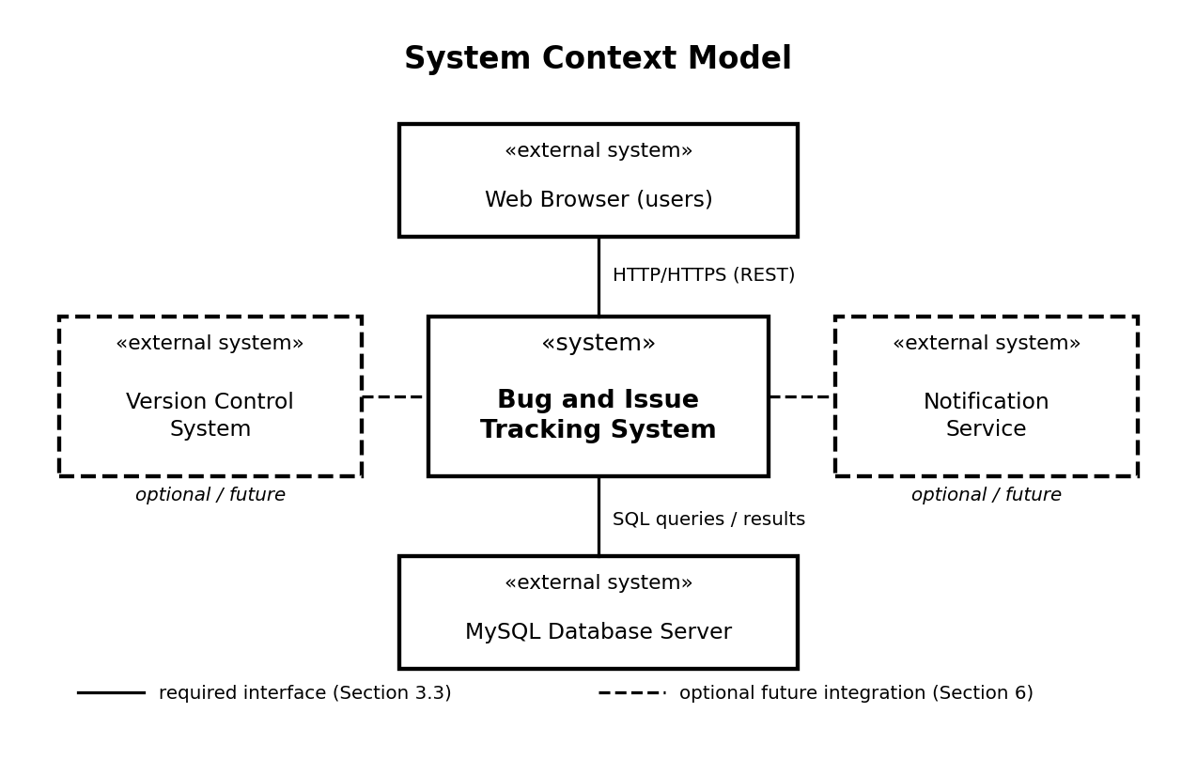
Figure 1. System Context Model
Figure 1 shows the Bug and Issue Tracking System as the central system, together with the main external systems in its environment: the web browser used to access the system and the MySQL database server (required interfaces, see Section 3.3), and a version-control system and a notification service (optional future integrations, see Section 6 and Appendix C). User management is an internal feature of the system, so it is not shown as an external system. The model intentionally does not show internal modules, database tables, or detailed data flows.

B.2 Additional Models
- ER Diagram — to show the main database entities and relationships.
- Activity Diagram — to show selected workflows such as issue resolution.
These detailed models can be added or refined after the requirements are approved and the implementation design is finalized.

B.3 Use Case Model
Figure 2 shows the primary actors and use cases for the planned first release. The diagram is a high-level view. All actors can also log in and log out (UC-01); this is omitted from the figure for clarity. Detailed role permissions are listed in Appendix C as still to be confirmed by the team.
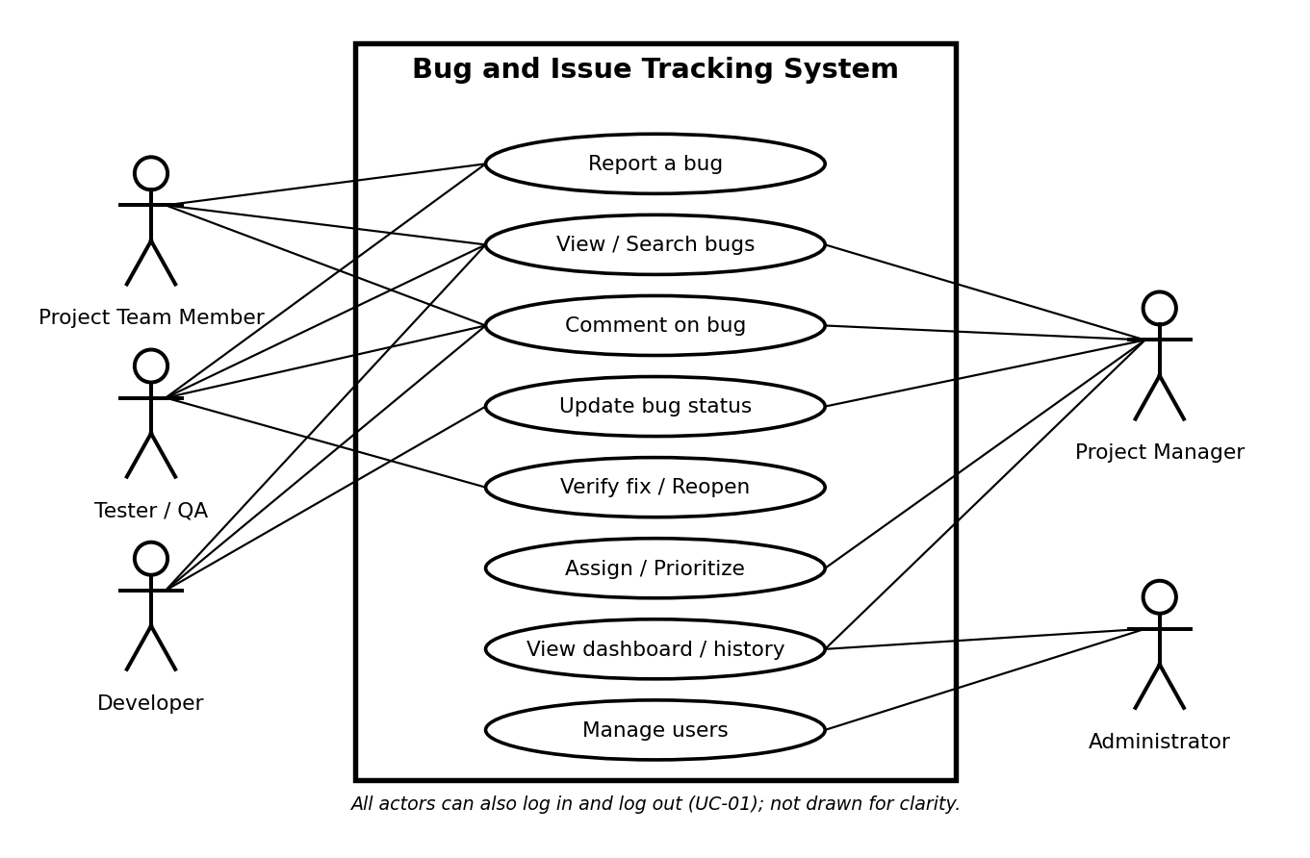
Figure 2. Use Case Diagram

B.3(a) Main Use Case Descriptions
Use case | Primary actor | Precondition | Main success flow | Alternative / exception
UC-01 Sign in | All roles | User account exists and is active. | User enters credentials; system validates them; dashboard opens. | Invalid credentials produce an error; no session is created.
UC-02 Report bug | Tester / Project Team Member | User is signed in. | User enters required details; system validates; saves record; displays bug ID. | Missing or invalid fields are highlighted and record is not saved.
UC-03 Assign bug | Project Manager | User is signed in with permission; bug exists. | Manager selects an assignee and saves; system updates assignment and history. | Invalid/inactive assignee is rejected.
UC-04 Update issue | Developer | User is assigned or otherwise authorized. | Developer opens issue, adds a comment or resolution note, and updates status. | Unauthorized update is rejected.
UC-05 Verify fix | Tester / QA | The issue is in Testing. | If the fix works, the tester marks it Closed. | If the defect remains, the tester marks it Reopened.
UC-06 Search issues | All signed-in roles | User has access to the project. | User enters keyword or filters; system displays matching issues. | No matches produces an empty-state message.
UC-07 Manage users | Administrator | User has administrator permission. | Admin creates/updates/deactivates account and assigns role. | Invalid data or duplicate account is rejected.

B.3(b) Sequence Model
Figure 3 illustrates a typical issue life cycle: the tester submits a report, the application validates and saves it, the project manager assigns it, the developer fixes it, and the tester verifies the result. The exact API endpoint names are illustrative and may change during implementation.
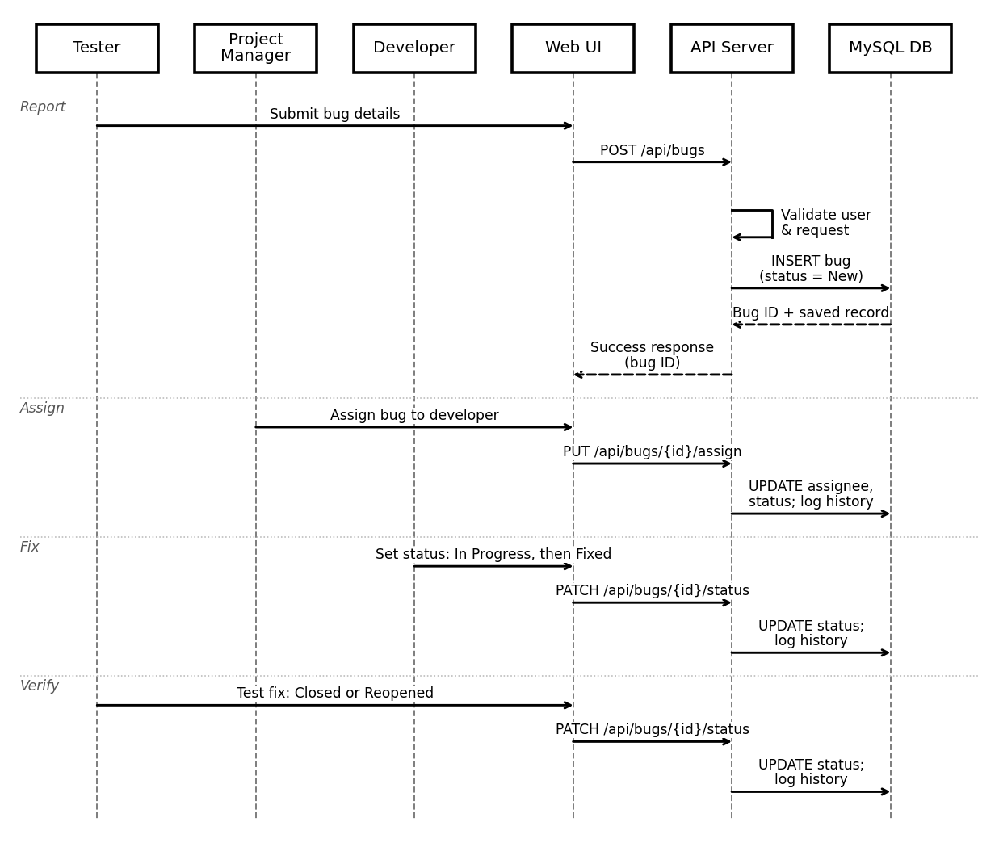
Figure 3. Sequence Diagram — Report, Assign, Fix, and Verify

B.3(c) Sequence Narrative
- The tester submits a bug report through the web interface.
- The frontend sends the report to the backend API.
- The API validates the user and request, then stores the issue in MySQL.
- The API returns the saved issue identifier and the frontend confirms success.
- The project manager assigns the issue; the developer investigates and records progress or resolution.
- The tester verifies the fix and marks the issue Closed or Reopened.
- The system persists the final status and relevant history entries.

Appendix C: To Be Determined List
1. Final visual design and color scheme of the web interface.
2. Exact maximum attachment size, if file attachments are included.
3. Whether external version-control or notification integration will be implemented.
4. Final database indexes after performance testing.
5. Final deployment environment and hosting method.
6. Detailed role permissions for each use case, to be confirmed by the team.

